TBS Support and Directions
Contacts:
https://tbsit360.com/support/ 630-537-1370
Technical Support: Helpdesk@tbsit360.com
Adam Jann, Support Technician, ajann@tbsit360.c0m
Mick Smith, Director of Sales, msmith@tbsit360.com
Papercut Printing Statistics:
To run printing reports, use the URL link below and login with the credentials provided. Login must be done on one of the two TBS Printing Portal laptops (either in the Reference workroom or Borrower Services) or on RPL protected network.
Once you have logged in, go to the Reports section (left-hand side of the page), and then under user Reports click on Printer. Individual printing reports are listed under this section. Go to the Printer usage summary for a report from the last month.
Papercut Admin portal: http://10.1.10.20:9191/admin
UN: tech PW: tech
To access wireless printing statistics, click on Logs (left-hand side of the page), and then under Job Log, scroll down and click Status: not cancelled, and then under Comment, type in Wireless. Image is below:
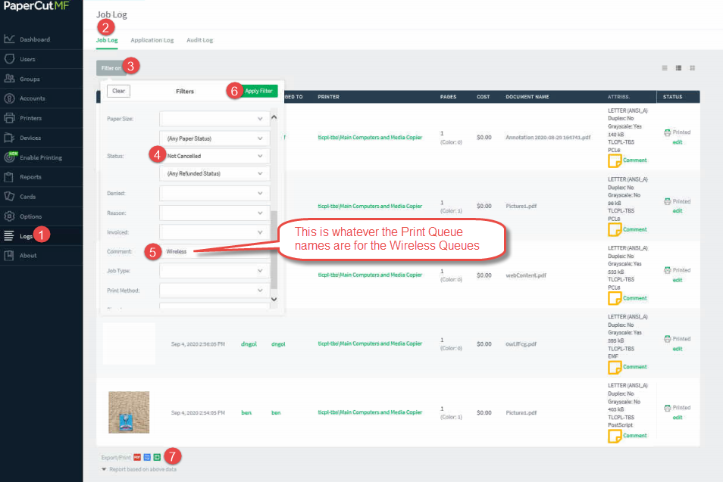
Basic information can also be accessed by logging in using the tech login, not the generic staff:
TBS Portal: http://10.1.10.20/tbsportal
UN: staff PW: staff UN: tech PW: tech

